**INTCDE21ID008**

**STAGE-3**

**916398 – SAAHIL TOMAR**

**Day 5 – ASP.NET CORE**

**Hands-On:**

Hello World !

**Startup.cs**

using Microsoft.AspNetCore.Builder;

using Microsoft.AspNetCore.Hosting;

using Microsoft.AspNetCore.Http;

using Microsoft.Extensions.DependencyInjection;

using Microsoft.Extensions.Hosting;

using System;

using System.Collections.Generic;

using System.Linq;

using System.Threading.Tasks;

namespace helloworld

{

public class Startup

{

// This method gets called by the runtime. Use this method to add services to the container.

// For more information on how to configure your application, visit https://go.microsoft.com/fwlink/?LinkID=398940

public void ConfigureServices(IServiceCollection services)

{

}

// This method gets called by the runtime. Use this method to configure the HTTP request pipeline.

public void Configure(IApplicationBuilder app, IWebHostEnvironment env)

{

if (env.IsDevelopment())

{

app.UseDeveloperExceptionPage();

}

app.UseRouting();

app.UseEndpoints(endpoints =>

{

endpoints.MapGet("/", async context =>

{

await context.Response.WriteAsync("Hello World!");

});

});

}}

}

**Program.cs**

using Microsoft.AspNetCore.Hosting;

using Microsoft.Extensions.Configuration;

using Microsoft.Extensions.Hosting;

using Microsoft.Extensions.Logging;

using System;

using System.Collections.Generic;

using System.Linq;

using System.Threading.Tasks;

namespace helloworld

{

public class Program

{

public static void Main(string[] args)

{

CreateHostBuilder(args).Build().Run();

}

public static IHostBuilder CreateHostBuilder(string[] args) =>

Host.CreateDefaultBuilder(args)

.ConfigureWebHostDefaults(webBuilder =>

{

webBuilder.UseStartup<Startup>();

});

}

}

**OUTPUT:**

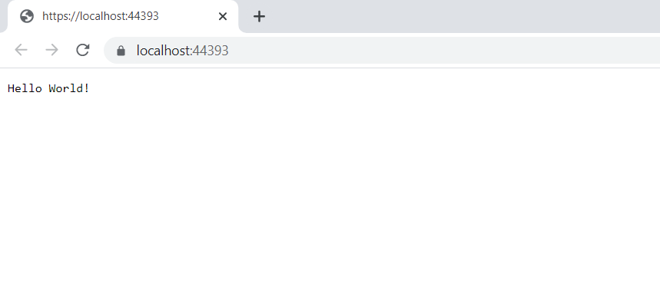

**MVC APPLICATION**

**File Structure**

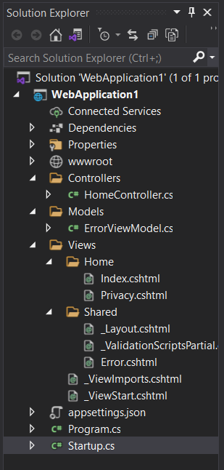

**OUTPUT:**

